LONDON METROPOLITAN UNIVERSITY

09
PROTOTYPE DEVELOPMENT OF ACTIVE CONDITIONAL MONITORING SYSTEM

ADEYEMI ADEKUNLE
06052450
M.Sc Computing.

Research and Development Skills (CCP155N)
ABSTRACT

The algorithm of the active conditional monitoring system was developed. The air safety system was analysed and the rate of accident and/incident was evaluated to see possible ways of reducing the mortality rate in the aviation sector. It was identified that the climbing and landing phases of flights has the highest risk factors. So to combat this, a project called ONBASS was started that. This project was aimed at developing a system that monitors aircrafts during flights in real time, getting and analysing recorded data and responding in quick time for aversion of accidents. The active conditional monitoring system is a part of this system that analyses the states of the elements of the aircraft by getting the states of the elements before, during and after flights and relating it to the normal functional state of that element.

TABLE OF CONTENTS

Abstract 2
Table of content 3
Rationale 4
Introduction 4
Scope 5
Aim and Objective 5
Literature Review 6
- Risk and Risk factor 7
- Flight Phases 9
- Risk reduction 10
Key Paper Review 11
Focused Appraisal 14
Conclusion 14
Architecture 15
Reference 16

RATIONALE
It is believed that for the achievement of low mortality rate in the aviation sector safety regulations must be reviewed and safety software technologies must be developed. This has given rise to new technologies in this sector and it includes the active safety system.

INTRODUCTION
The safety of the air transport system has been a major concern in the aviation industry and the global economy in general, this has led to various developments of safety equipments to monitor and control rates of “accidents” (which is an event when any person suffers death or serious injury and aircraft receives substantial damage), or “incidents” (which is an occurrence different from an accidents associated with the operation of an aircraft which could affect safety of operations ) in this sector [1]. The development of safety systems in the aviation sector has grown rapidly with the changing and moderation of aviation rules and regulations. This growth gave rise to the development of Principle of Active Safety Systems (PASS). This system was designed to record, analyse, predict and propose possible aversion of air accidents or incidents [2]. Active conditional monitoring system is a part of this system for monitoring elements of an object (aircraft) before and during take-off, during flights, and landing in real time. This system will not only monitor the aircraft but also alert the right authority e.g the pilot, control tower, e.t.c, of any potential damage and/or accident in terms of the elements or the equipments of the aircraft. The system also records the condition of the aircraft at any particular point in time putting into consideration data recorded from previous flights and the different states of the elements or components and determining normal and abnormal states for further analysis.

SCOPE
This project is useful not only in the aviation sector but in the transport industry in general. This system can give rise to other systems developments for monitoring and applying safety control devices in different forms of transportation. It gives rise to research and development of transport hardware components which are fault tolerant.

AIM AND OBJECTIVES
The aim of this research is
- To develop an algorithm for the development of a prototype software system that monitors the different active elements of an aircraft in real time for analysis aimed at predicting, preventing and/or reducing air accidents.
- Open up further research for air safety systems
And the objective of this research is
- To develop a prototype system that can be used to analyse the state of elements that make up an object and thus reduce incidents and accidents in the aviation sector and transportation in general using an object oriented language called Oberon.
This will be achieved by
- First analysing the different elements that make up the object (aircraft).
- Then relates these with the flight recorded data
- Then analyse these states noting deviations to determine abnormal states and predicting levels of harm using probabilities.
- Triggering sequence of information in real time for possible reaction to the abnormal states.
- Sending information to other aspects of PASS.
- Open more research area that can be a foundation for the development of further and complex active safety systems in general transportation.

ACTIVE CONDITIONAL MONITORING SYSTEM – a REVIEW
The aviation sector is divided into different sectors considering different factors which include the flights mission, the mode or method of operation, the technical specification and the state of development of the aircraft [2]. But generally it can be divided into two; military and civil aviation. The military aviation safety will not be looked in detail because of high sensitivity in the information, but the safety procedure had been adapted to the function of the hardware and software of the planes basically because it contains at most two pilots and has been modified for combats and other special functions.
The civil aviation sector is further divided into two, namely general aviation (GA) and commercial aviation (CA) [2]. In this sector, the safety regulation and analysis has been improving over the years most especially in the commercial aviation but the risk and safety in the general aviation still possess a low turnout in the aviation . This led to the development of a project called ONBASS (on board active safety systems) in 1994[3]. This system proposed a way of monitoring the general functionalities of an air craft in to know at any particular point in time what the cause of incidents or accident is/are and suggest ways of averting or reducing the cause.

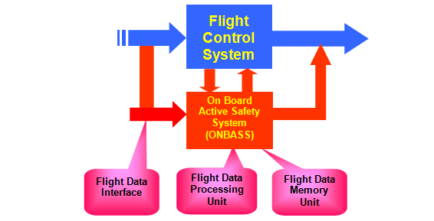

Fig 1 Overview of the ONBASS System [3]

It was observed that the aviation industry is being affected by some critical factors which are
- The increase in air traffic
- The increase in complex aircrafts
- Increasing passengers
- High maintenance overheads
- Increase in luggage capacity.
Along with these factors came the increase in theoretical and technological advancements and these have led to the increase of risks.
RISK AND RISK FACTORS
During the last 40 years, statistics has shown that there have been improvements in the aviation safety in the CA sector. This shows that the number of accidents has been reduced to 1 per 5 per million departures (fig 2) [4]
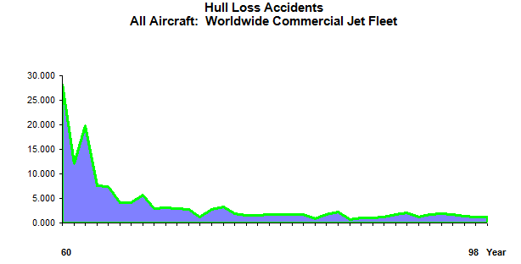
Fig.2. Accident statistics per million departures (Source [5])

But still with the statistics above, other sectors still has great danger and high risk of accidents and incidents, most especially in GA sector.
Many factors affect risks, some of which include loss of control in flights, control flights in terrain, mechanical malfunctioning, mid-air collision, environmental and climatic conditions [4]. Other factors that influence risk factors are human, equipment factors. These factors affect flights at different phases. These flight phases are
- The taxi-out phase
- The climbing phase
- The in- flight phase
- Descent phase
- Taxi in phase
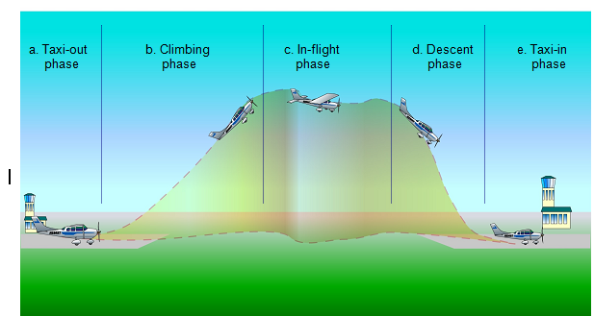

Fig 3. Typical flight phases [ source 3]
The statistics of aviation accidents showed that a great proportion of accidents occur during the climbing (take-off) and descent (landing) phases of flights [7].

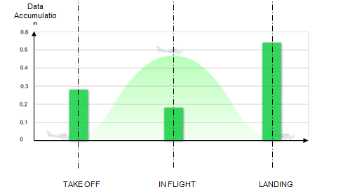
Fig.4 Statistics of accidents in phases [7]
And from this figure above the accident in GA is ten times these statistics but with the same graphical curve. For the reduction of these accidents, the risk profile for all phases most especially the dangerous phases must be monitored and managed and be brought to about nearest minimum.

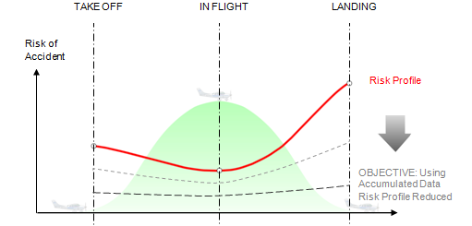
Fig 5. Propose Level of Risk Reduction[7]

During the flight phases, the states of the elements of the aircraft are recorded and analysed for safety. This is done by the deviation between the normal functional state and the flight state in each phase, getting the deviation and predicting probable occurrence of accidents/ incidents and suggesting different solutions to avert the event occurring [8].
For the analyses of these data, existing systems of objective checking (SOC) assumed that the greater the amount of data about the states of the element the better the analysis of condition of in-flight which is use to evaluate and make recommendation for post-flight logistic analysis [8].
But this system only makes analysis when, for example the accident/ incident have occurred and nothing to be done about it. But the base technology of the PASS surpasses this as it records and possibly gives immediate reaction for aversion of accident.

KEY PAPER REVIEW
APPLYING THE PRINCIPLE OF ACTIVE SAFETY TO AVIATION

Igor schagaev, in is paper published in 2005 showed the application of active safety system to aviation in which the modelled active safety system called MASSA shown below was implemented to see the level of PASS in the aviation safety.
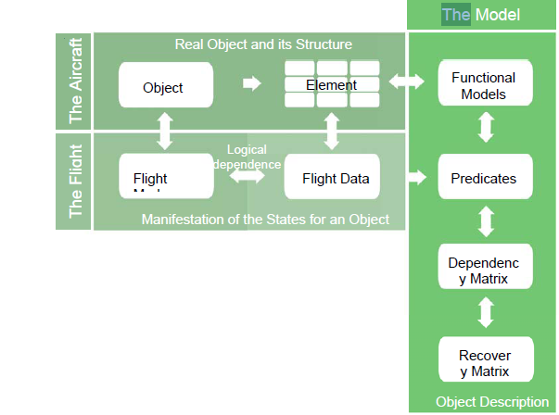

Fig.6. THE MASSA STRUCTURE [ source 4]

This model was developed to tackle the minimization of accidents cause by improper evaluation of information about the flight data and also improper evaluation or diagnosis of faults by the maintenance practice for technical systems. He went on further to analyse the dependency of data and elements as shown below

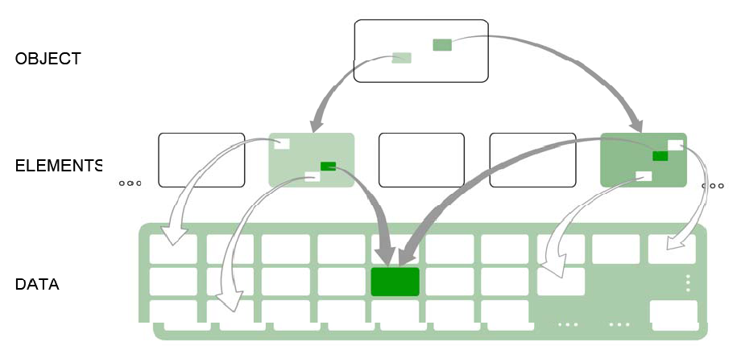

Fig.7. Dependency of data and elements [source 4]

But the states of the elements in the flight data using dependency matrix with predicates P to analyse the possible faults by the formula

Where p = predicates, m = model, e = elements, d = data, t = time.

The state of the elements as measure with the vector P propagates the dependency matrix R in terms of faults influence and propagation. In simple terms “detects faults states of the elements”. Dependency matrix can be done either as a square matrix with n columns or with m*n columns. Other mathematical techniques that can be used include Boolean matrix, undirected graphs and probabilistic graphs.
He went further to say that after the faults have been detected, the recovery matrix R_{m} then determines the reaction to the faults propagated using the same dimension of matrix[3].
The general algorithms for this sequence of action can be represented by the diagram below

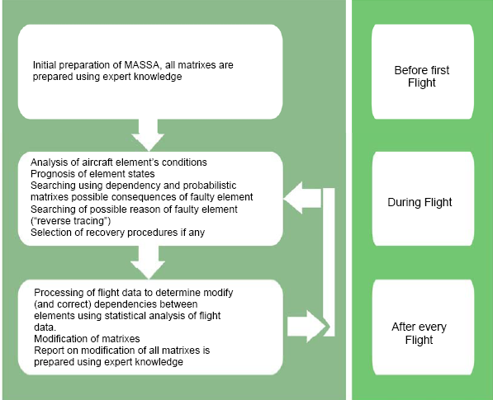

Fig 8 The on- board and on-ground phases of PASS algorithms [5]

This principle was however concluded that for its implementation, the safety of the phases of flights could be monitored, analysed and response initiated in real time.
He gave the algorithm for the implementation of PASS using the forward and backward tracing paths. These paths search the consequences of faults in elements using probabilities, ranking the faults and records the anomalies in terms of risks and potential damages.
He concluded the paper by stating that the paper presented a new approach to the monitoring of aircraft behaviour in real time and also the design and development of model that describes the fault influence dependencies between elements and how to analyse the process for prediction of accidents and possible ways of aversion.

FOCUSED APPRAISAL
From the analysis of the project above, some areas are still needed to be explore and research upon and the this include the real time analysis of recorded data for safety management.

CONCLUSION

ACHITECTURE

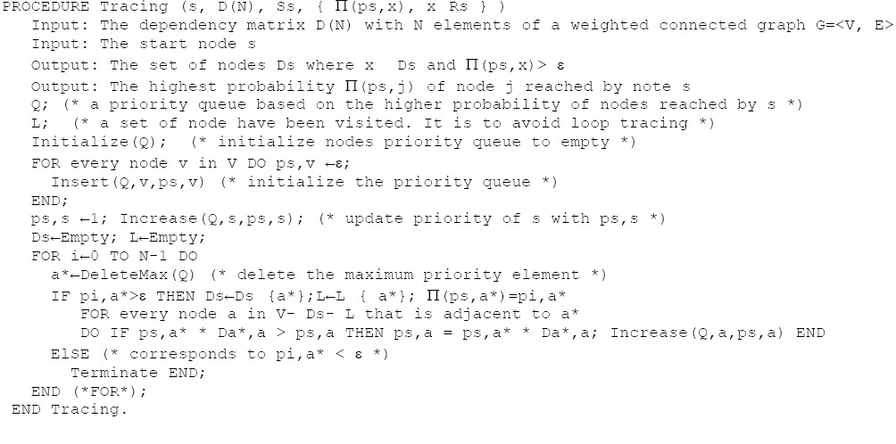
Fig 9. Forward tracing path [7]



Fig 10. Reverse Tracing [7]

REFRENCE

- Federal Aviation Administration, 1998, Washington, DC
- ONBASS project, Deliverable 1.2 ONBASS Consortium, 2005,
- PASS
- Weener E., “Aviation Safety for the 21st century”, Invited Lecture 1998 ISSSC, Seattle.
- United states GAO (General Accounting Office), GAO-01-96, “General Aviation Status of the Industry, Related Infrastructure, and safety Issues”, Report to Congressional Requester, August 2001.
- Earl F. Weener 98 Commercial aviation Safety Challenges for the 21st Century, Presentation to Systems safety Conference September 16, 1998
- Annex 1 – “Description of work”, Version 3.1, dd 12/11/2004, for ONBASS. Contract of the 6th European Framework Program: “Integrating and Strengthening the European Research Area, Thematic Priority” : Aeronautics and Space, Contract No: AST4-CT-2004-516045
- Igor Schagaev., “Concept Of Dynamic Safety for Aviation” , 16th ISSC 1998, Seattle
- Schagaev I ., Applying The Principle Of Active Safety To Aviation, 2nd EUCASS on Avionics, Control Systems and Information Technologies 2005
- Schagaev I., Concept of Active System Safety. In Proc. 15th IFAC Symp. On Automatic Control in Aerospace Bologna/ Forli, Italy September 2001
- Bukov V.N., Systems Embedding. Analysis and Design of Matrix Systems: An analytical approach. Kaluga: N Bochkareva Publishing house, 2006
- Kirk B.R., Schagaev I.V., Method and Apparatus of Active System Safety. UK Patent Filing P54341GB, 2007
- Birolini A., Reliability Engineering, 4th Edition, Springer Verlag, 2004
- Aviziensis A., Laprie J-C., Randell B., Fundamental Concepts of Computer Systems Dependability. In IARP/ IEEE-RAS Workshop on Robot Dependability Seoul, Korea, May 21-22, 2001

